V-MODEL(SDLC)

The V-model is a type of SDLC model where process executes in a sequential manner in V-shape. It is also known as Verification and Validation model. It is based on the association of a testing phase for each corresponding development stage. Development of each step directly associated with the testing phase. The next phase starts only after completion of the previous phase i.e. for each development activity, there is a testing activity corresponding to it.

The V-Model is a software development life cycle (SDLC) model that provides a systematic and visual representation of the software development process. It is based on the idea of a “V” shape, with the two legs of the “V” representing the progression of the software development process from requirements gathering and analysis to design, implementation, testing, and maintenance.

**The V-Model is a linear and sequential model that consists of the following phases:**

1. Requirements Gathering and Analysis: The first phase of the V-Model is the requirements gathering and analysis phase, where the customer’s requirements for the software are gathered and analyzed to determine the scope of the project.
2. Design: In the design phase, the software architecture and design are developed, including the high-level design and detailed design.
3. Implementation: In the implementation phase, the software is actually built based on the design.
4. Testing: In the testing phase, the software is tested to ensure that it meets the customer’s requirements and is of high quality.
5. Deployment: In the deployment phase, the software is deployed and put into use.
6. Maintenance: In the maintenance phase, the software is maintained to ensure that it continues to meet the customer’s needs and expectations.
7. The V-Model is often used in safety-critical systems, such as aerospace and defense systems, because of its emphasis on thorough testing and its ability to clearly define the steps involved in the software development process.

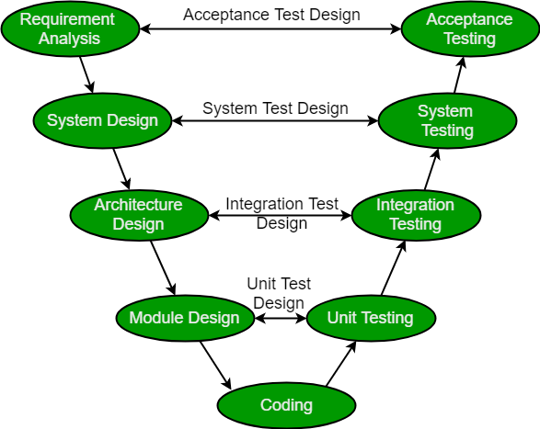

**Verification:** It involves static analysis technique (review) done without executing code. It is the process of evaluation of the product development phase to find whether specified requirements meet.

**Advantages:**

* This is a highly disciplined model and Phases are completed one at a time.
* V-Model is used for small projects where project requirements are clear.
* Simple and easy to understand and use.
* This model focuses on verification and validation activities early in the life cycle thereby enhancing the probability of building an error-free and good quality product.
* It enables project management to track progress accurately.
* Clear and Structured Process: The V-Model provides a clear and structured process for software development, making it easier to understand and follow.
* Emphasis on Testing: The V-Model places a strong emphasis on testing, which helps to ensure the quality and reliability of the software.
* Improved Traceability: The V-Model provides a clear link between the requirements and the final product, making it easier to trace and manage changes to the software.
* Better Communication: The clear structure of the V-Model helps to improve communication between the customer and the development team.

**Disadvantages:**

* High risk and uncertainty.
* It is not a good for complex and object-oriented projects.
* It is not suitable for projects where requirements are not clear and contains high risk of changing.
* This model does not support iteration of phases.
* It does not easily handle concurrent events.
* Inflexibility: The V-Model is a linear and sequential model, which can make it difficult to adapt to changing requirements or unexpected events.
* Time-Consuming: The V-Model can be time-consuming, as it requires a lot of documentation and testing.
* Overreliance on Documentation: The V-Model places a strong emphasis on documentation, which can lead to an overreliance on documentation at the expense of actual development work.